**Desktop Application**

**Step 1:** Click the FaceCode icon to run the desktop application.

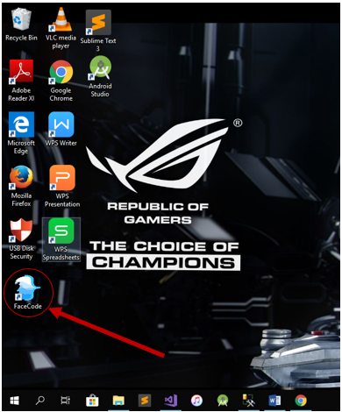

**Create Account for Admin**

**Note:** You must create an account first in order to access the desktop application.

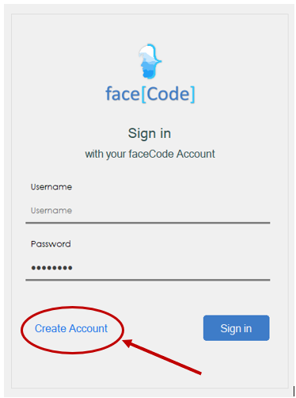

**Step 2**: Input your personal information including the username and your password for the authentication purposes. After that, click “Create button” to save your account.

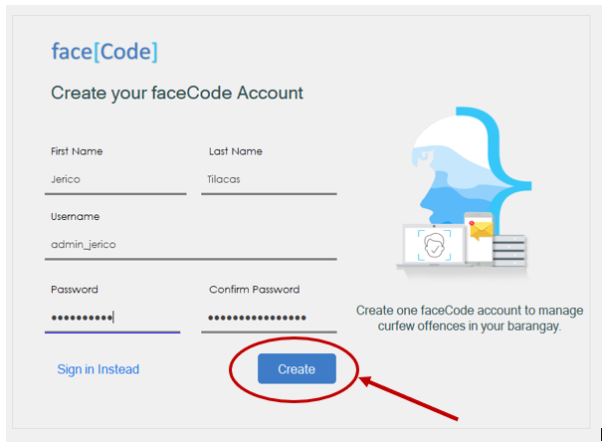

**Step 3:** Login your account in order to access the system.

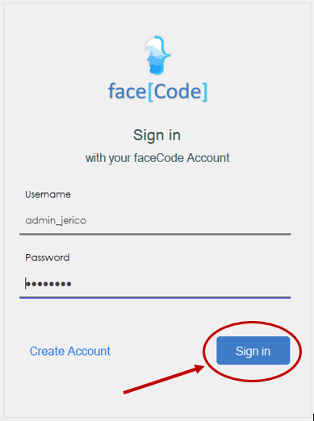

**Add Juvenile Offender**

Assuming you have successfully logged in into the system. Proceed to step 4.

**Step 4:** Click the add offender icon if you need to add information of the juvenile who has committed an offense.

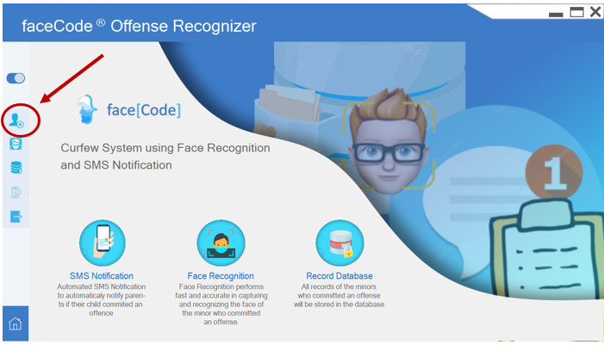

If you click the add offender, the add offender interface will appear.

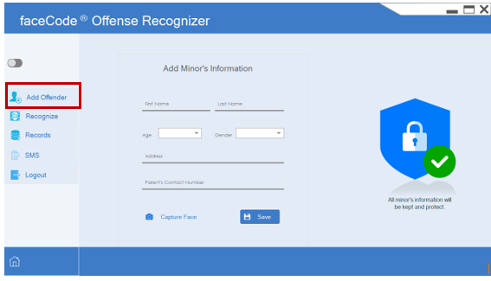

In this interface, you can now add the personal information of the minor offender. Fill all the fields needed then click capture face button to capture the face of the minor. 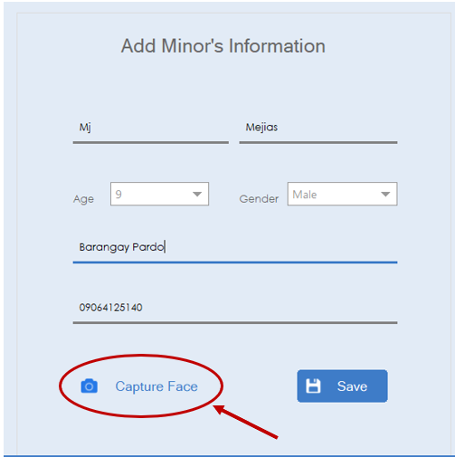

**Step 5:** By clicking the capture face button, the camera interface will display and you can now capture the face of the juvenile offender.

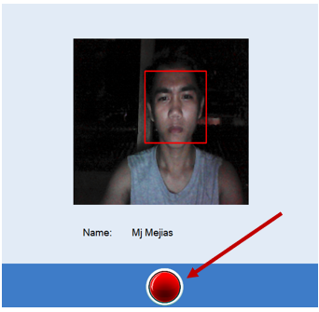

Press the red button to save the photo.

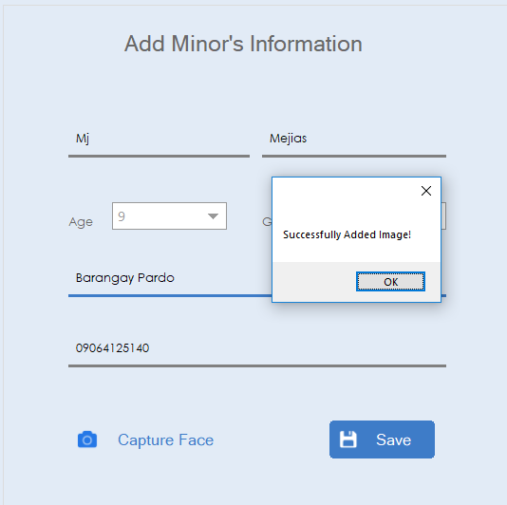

After that, you can now save the information of the minor by clicking the save button.

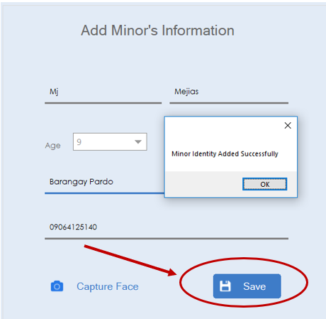

**Records**

All information will be stored to the records. In this interface, you can add, remove and search for the data of the offender. By removing any data of the minor, click first their name and you can delete their data.

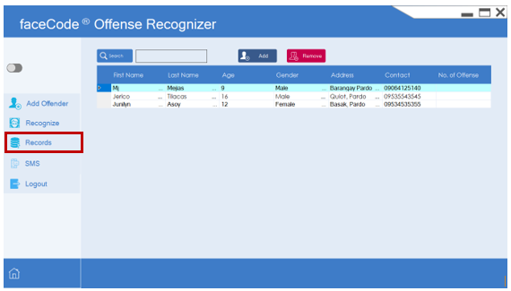

**Face Recognition**

For the 2nd offense, you can automaticaly recognize the face of the minor to identify if he/she already have committed an offense.

**Step 6:** Click the recognize button to start recognizing the face of the minor offender.

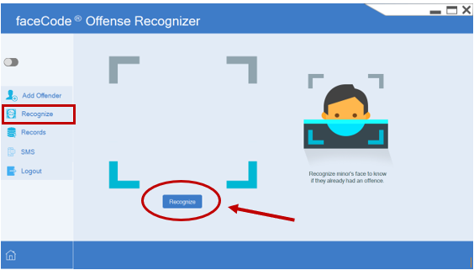

After recognizing the face, it will automatically display the information of the minor offender.

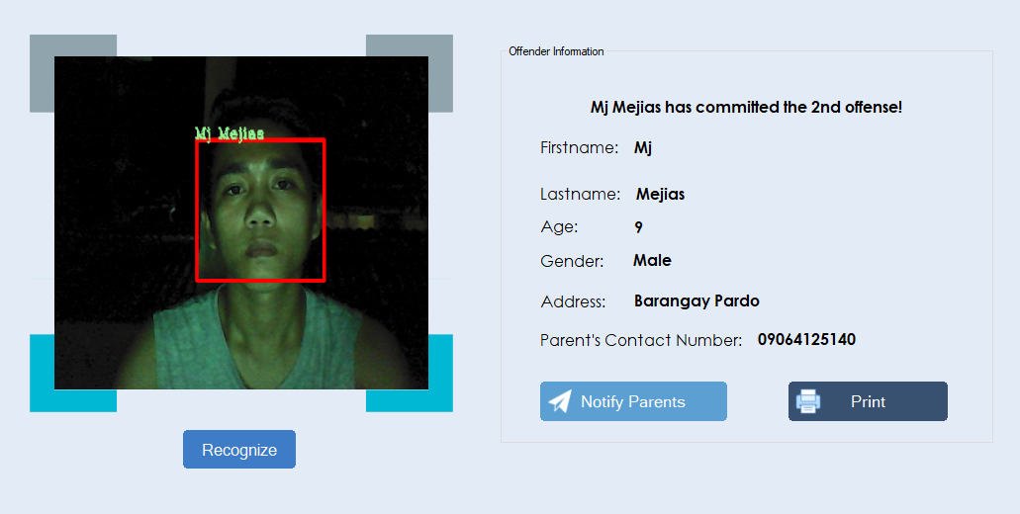

**Note:** If the face of the minor was not recognized, it will display the “no record found”, it means there’s no existing record of the minor.

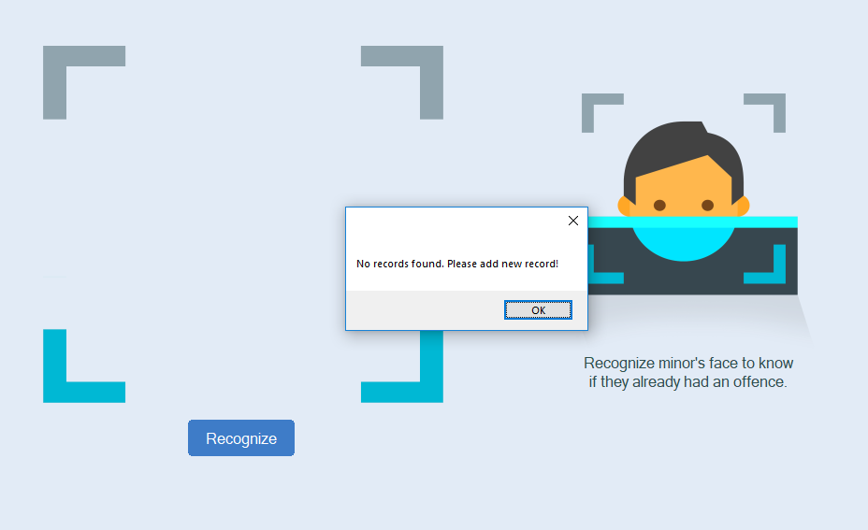

**SMS Notification**

**Step 7:** In SMS Notification, you can automatically notify the parent who committed an offense. By clicking the notify parent button, the parent will received a message that their child has violated the curfew.

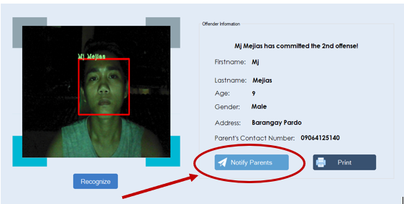

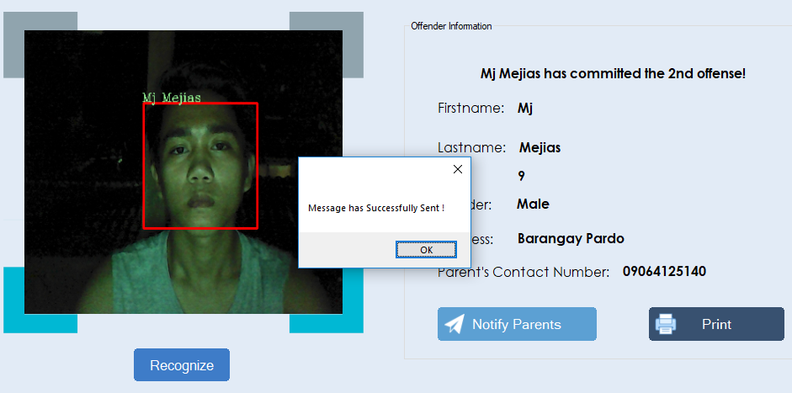

This is the message that have been sent to the parents of the minor child who has committed the offense.

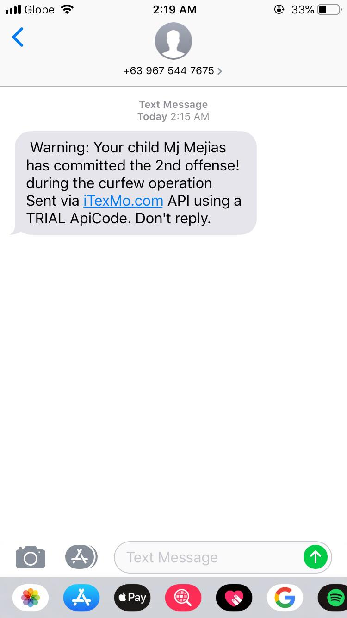

**Note:** You can compose your own message that you want to address to the parents regarding for their issues.

**Step 8:** Click the sms button to compose a message for the parent of the minor, then click send.

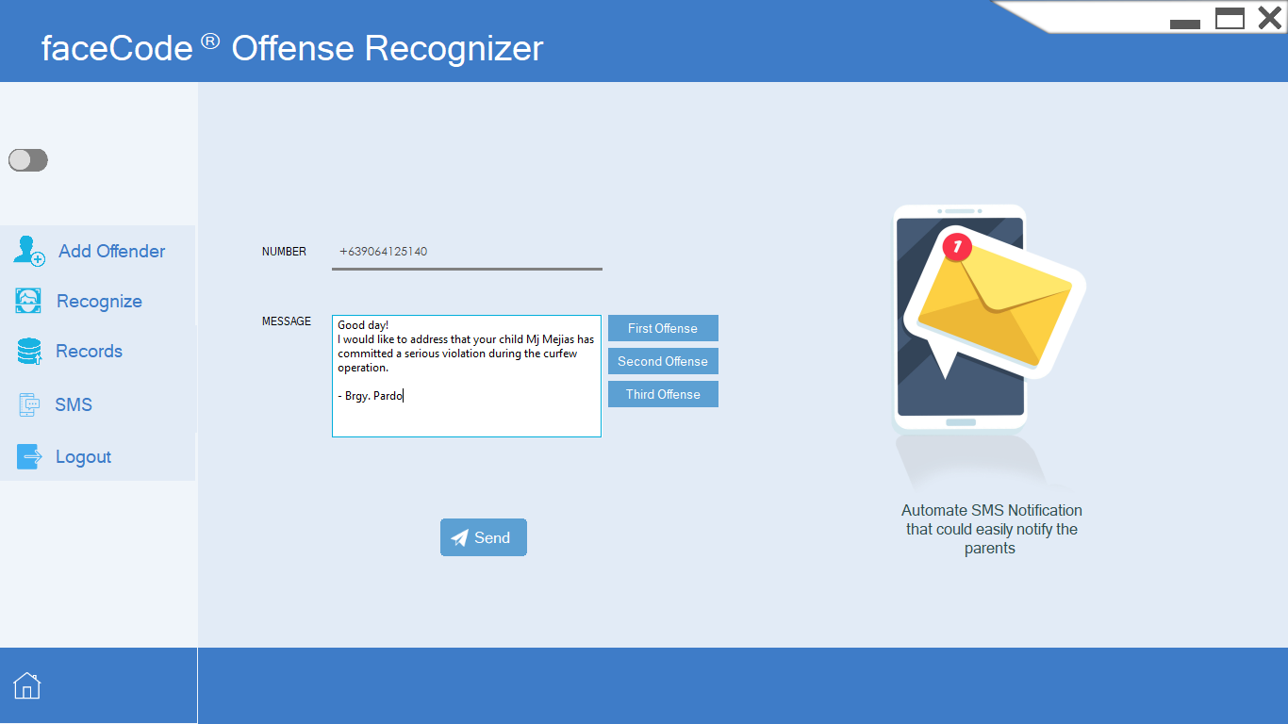

**Print Preview**

You can decide whether you want to print a copy for the information of the minor in order to send a report to DSWD knowing that this certain child has committed a serious violation.

**Step 9:** Click the print button in order to have to print document for the data of the minor offender.

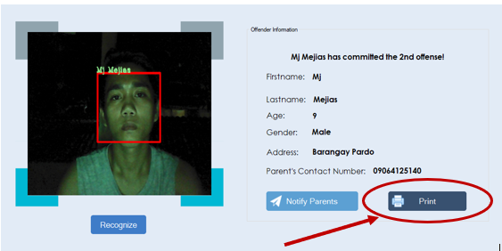

This will be the copy of the printed document that contains the information of the minor offender.

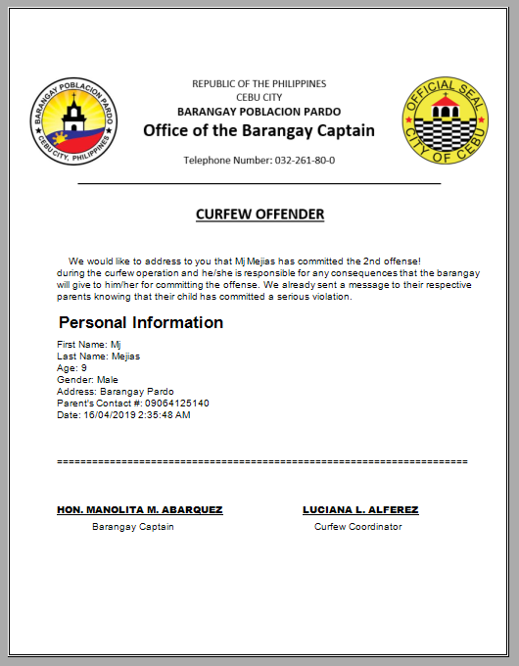

After printing the document, you can proceed any of these steps or you can logout.

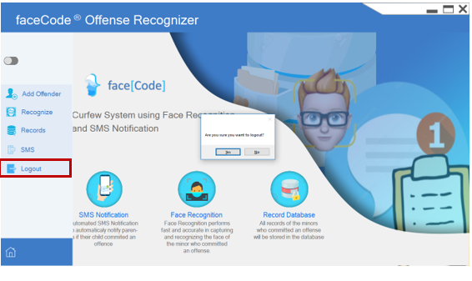

**SQL Server Instance Installation**

**Step 1** Open up the SQL Server 2008 installation file you have downloaded and select "Installation" from the side panel. Then select "New SQL Server stand-alone installation".

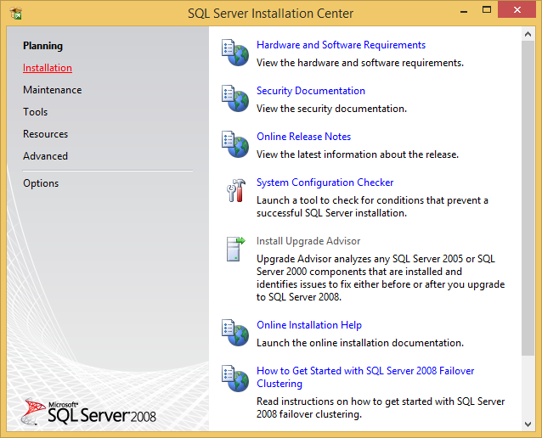

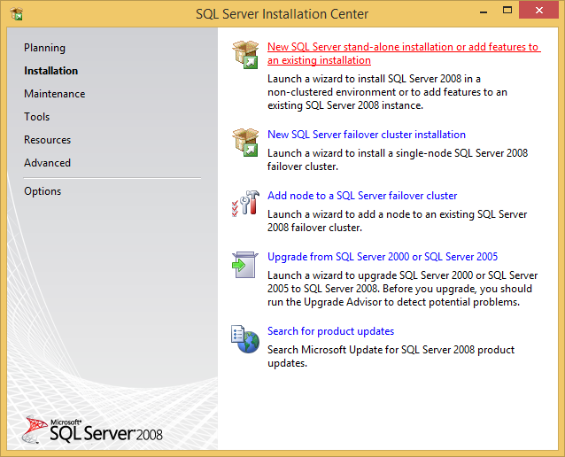

**Step 2:** Continue through the installation just by hitting Next, until you get to "Feature Selection" page. The only feature you should select is "Database Engine Services" since the others are not used. Then click Next.

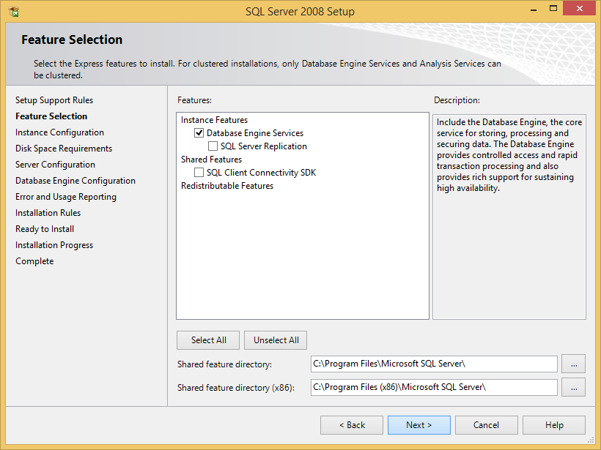

**Step 3:** For the "Instance Configuration", LEAVE THE INSTANCE NAME AS SQLExpress. I would only suggest changing this if you are an experienced user. After this, click Next.

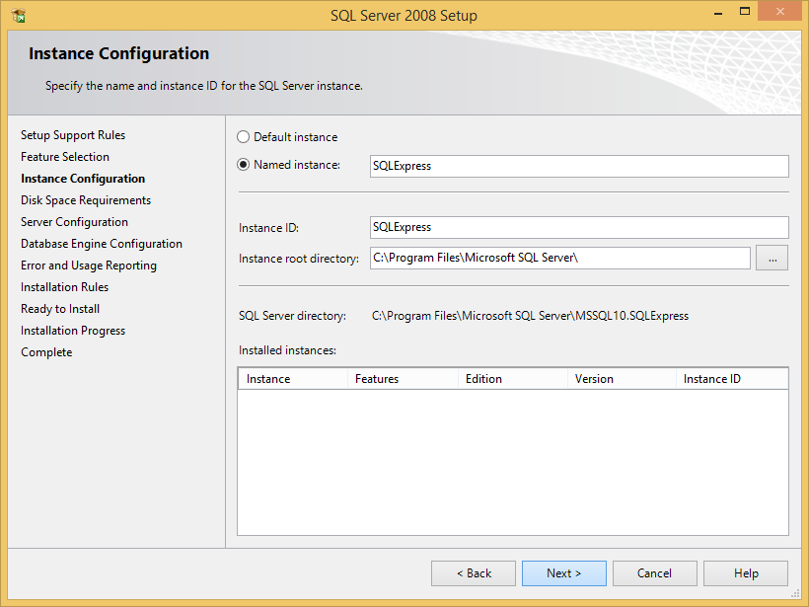

**Step 4:** For the "Server Configuration", set the Account Name as a NETWORK SERVICE, and leave the start-up type as Automatic. "The SQL Server Browser" should be set as Disabled. After this, click Next.

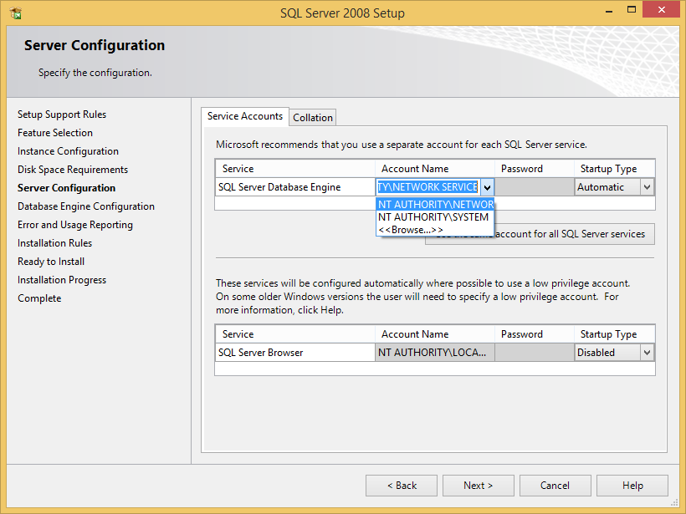

**Step 5:** For the "Database Engine Configuration", select Mixed Mode as the Authentication Mode, and enter a password that you won't forget. This is what you will use for remote access to the database (such as from websites). Also, **make sure** to add the current user as an "SQL Server Administrator". This will give the current user unlimited access over the database. After this, click Next.

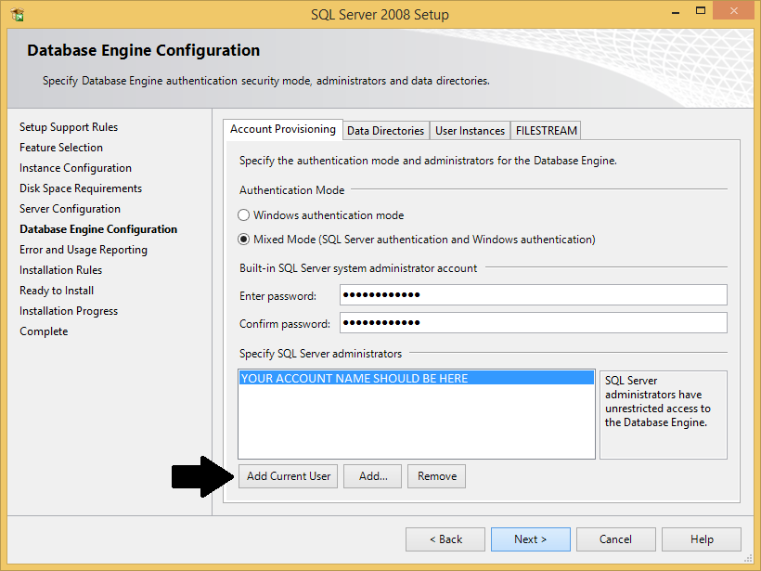

**Step 6:** After the successful installation message, you're all done.

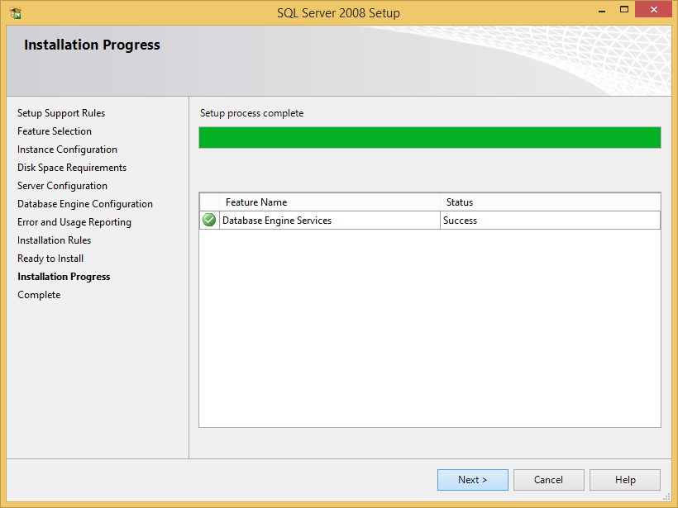

**SQL Server Management Studio Express Installation**

**Step 1:** This setup is very similar to the SQL Server installation, with a few minor differences. To begin, Open up the SQL Server Management Studio Express 2008 installation file you have downloaded and select "Installation" from the side panel. Then select "New SQL Server stand-alone installation".





**Step 2:** It will ask if you want to make a new installation or modify your existing instance. This is a little confusing, but you should perform a **new** installation! After this, click Next.

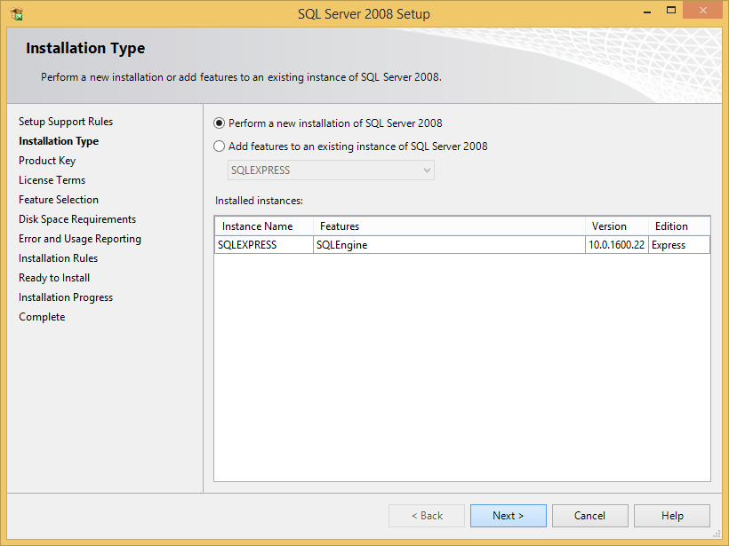

**Step 3:** For the "Feature Selection", make sure that "Management Tools - Basic" is enabled. After this, click Next.

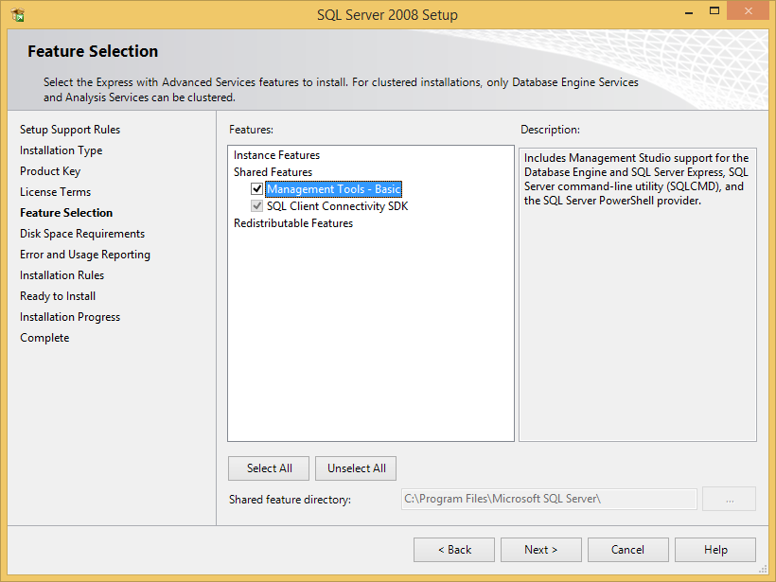

**Step 4:** After the successful installation message, you're all done.

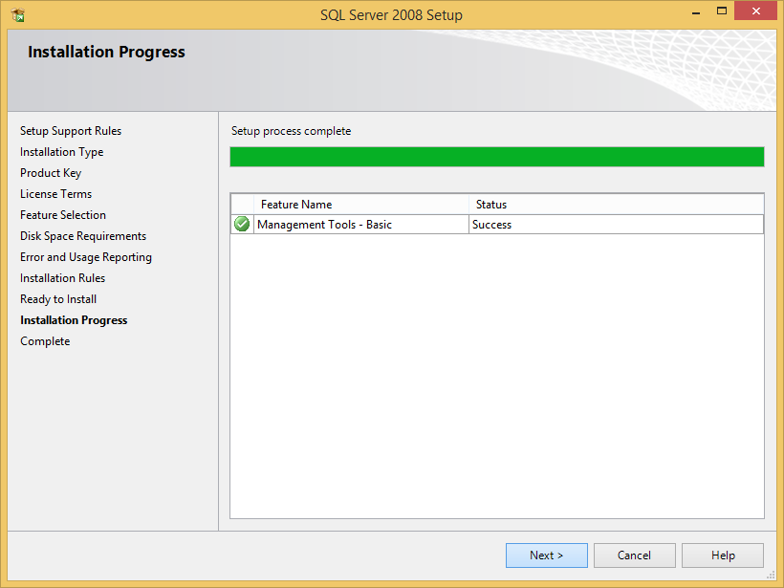

**Database Setup**

**Step 1:** To setup the database, all you need to do is execute one script and everything will be set-up. No messing with restoring databases, no messing with linked servers, it is all done in one step with my script!

Just open up SQL Server Management Studio (SSMS) and connect to ".\SQLEXPRESS" using Windows Authentication. (If you did change your Instance name for some reason, this will obviously be different!)

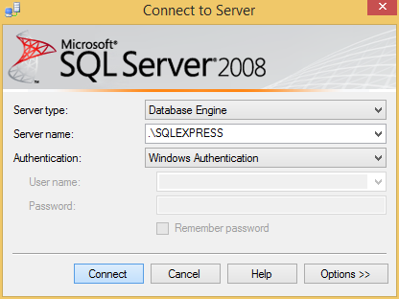

**Step 2:** Download and open the file “https://bit.ly/2H7pqpN” with SMSS and just hit Execute on the toolbar.

